DESIGN TABLES FOR PRODUCT AND CATEGORY ENTITIES.
Project Title: E-Commerce Order Management Database System

Project Title : E-Commerce Order Management Database System
Student Name : Thirupathi M
Register Number : C4S38023
Department : B.Sc Artificial Intelligence
Course : Artificial intelligence (AI)
Academic Year : 2024 – 2027

DBMS Practical - Product and Category Module
E-Commerce Order Management Database System
1. Create Database
CREATE DATABASE Ecommerce;
USE Ecommerce;
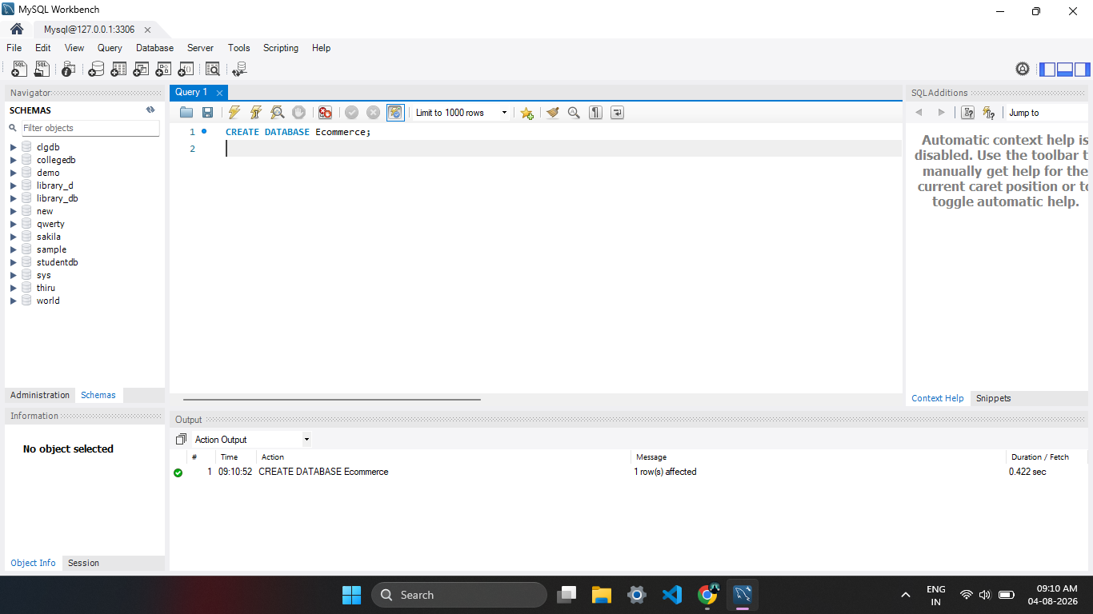

2. Create Category Table
CREATE TABLE Category (
CategoryID INT PRIMARY KEY,
CategoryName VARCHAR(50)
);

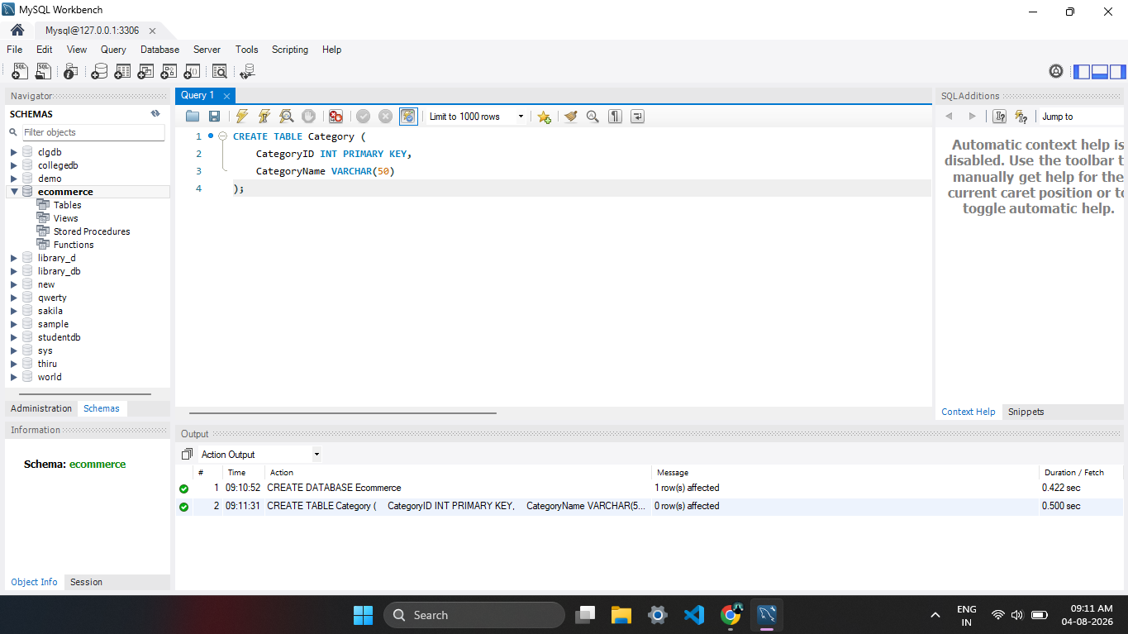
3. Create Product Table
CREATE TABLE Product (
ProductID INT PRIMARY KEY,
ProductName VARCHAR(50),
CategoryID INT,
Price INT,
Stock INT,
FOREIGN KEY (CategoryID) REFERENCES Category(CategoryID)
);
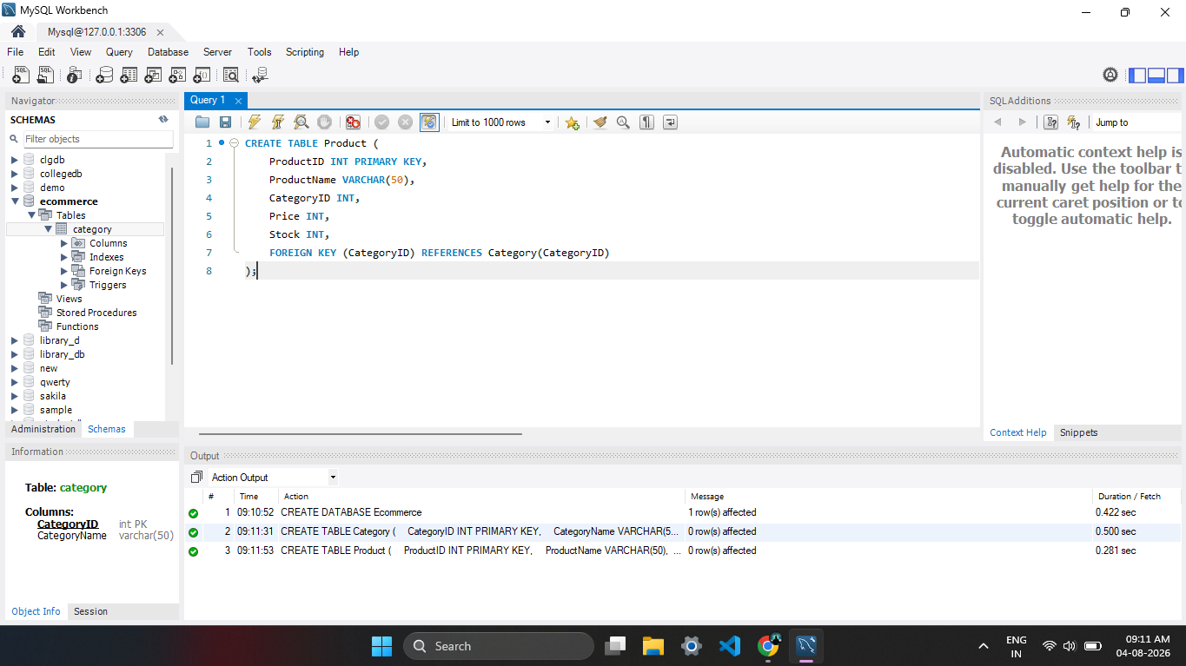

4. Insert Categories
INSERT INTO Category VALUES
(1, 'Electronics'),
(2, 'Clothing'),
(3, 'Books');
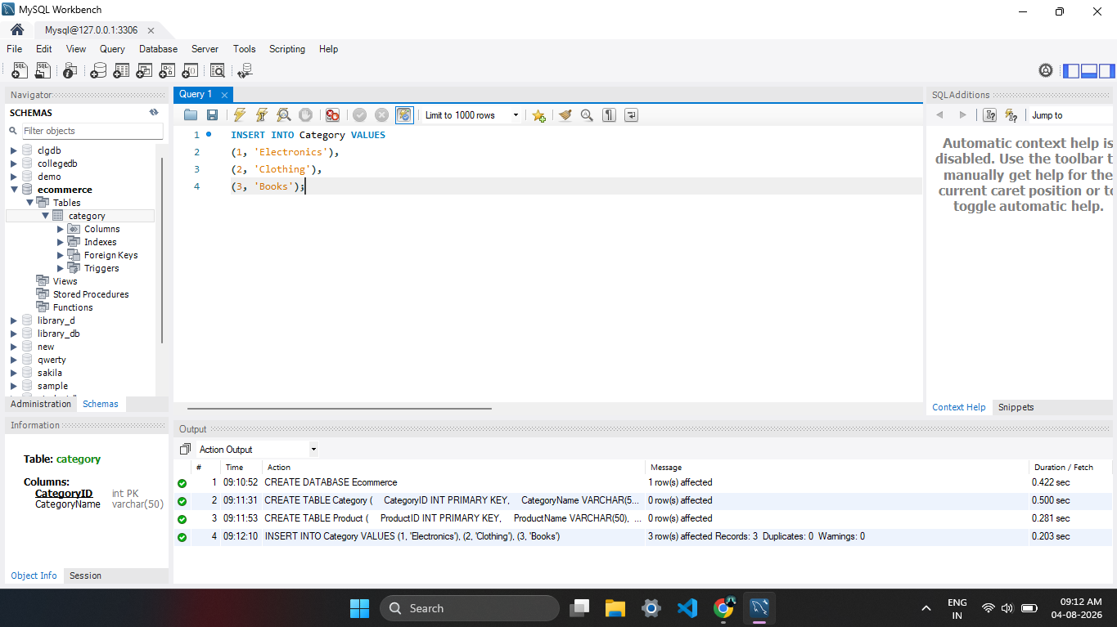

5. Insert Products
INSERT INTO Product VALUES
(101, 'Laptop', 1, 50000, 10),
(102, 'Mobile', 1, 20000, 20),
(103, 'T-Shirt', 2, 800, 50),
(104, 'Java Book', 3, 600, 30);
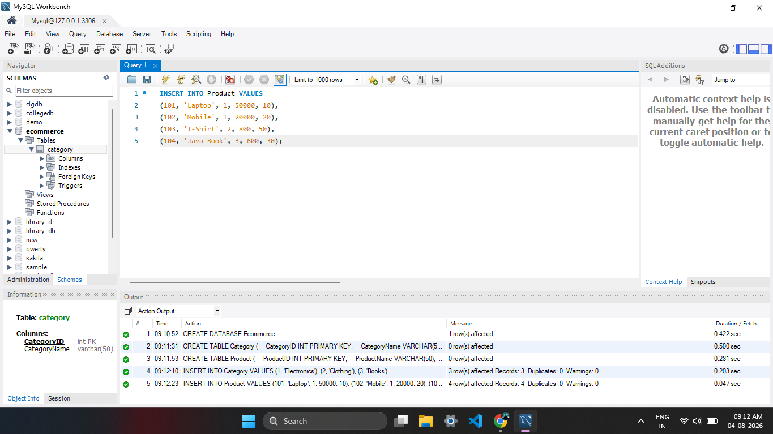

6. Display Products
SELECT * FROM Product;

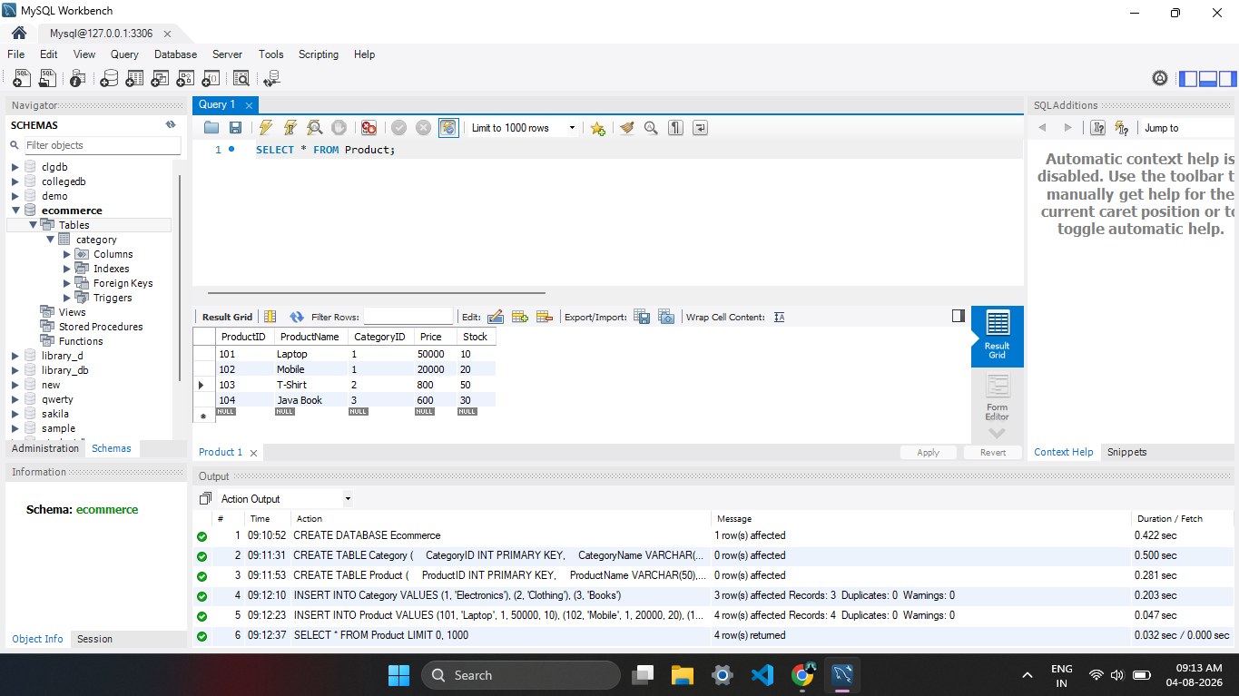

7. Update Product
UPDATE Product
SET Price = 55000
WHERE ProductID = 101;
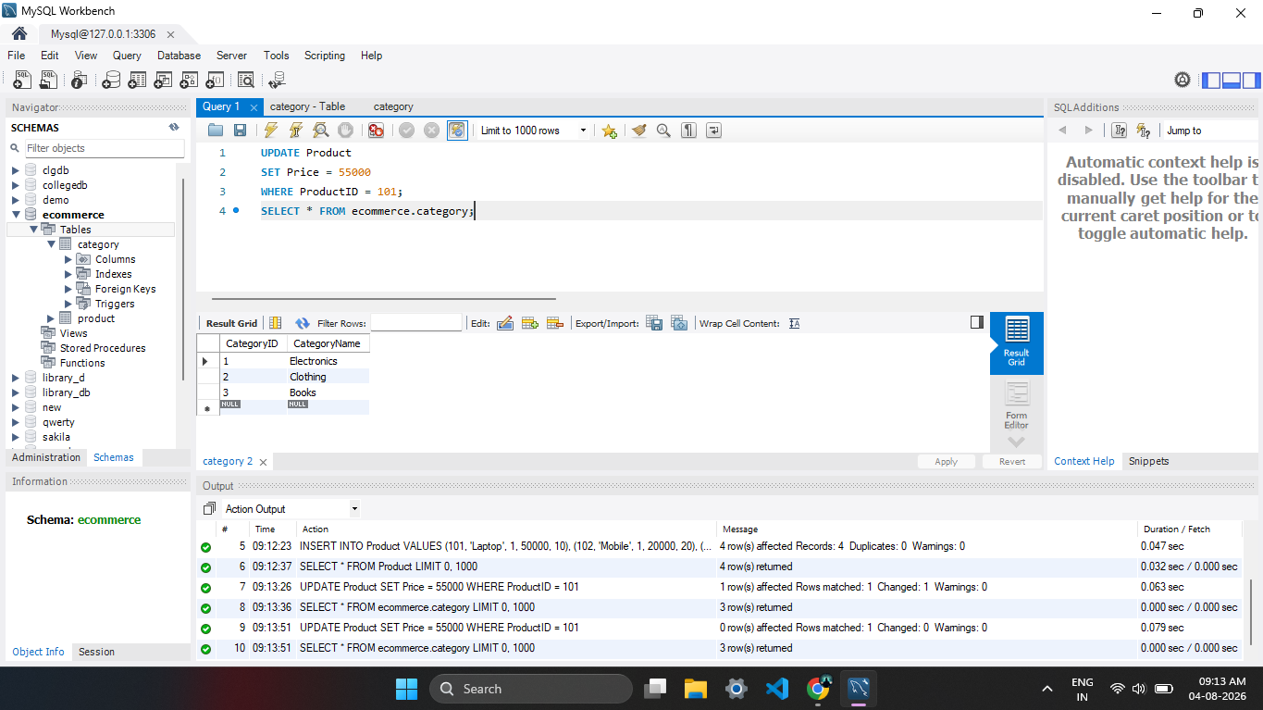

8. Category-wise Product Report
SELECT Category.CategoryName, Product.ProductName, Product.Price
FROM Category
JOIN Product
ON Category.CategoryID = Product.CategoryID;
